Elite Open Water Swim Camp 2013
Date: July 3rd at NOON to July 7th at 2pm.  Cost: $695 overnight $495 day campers  Location: Athletes will be lodged at the Tropicana Gardens dorms adjacent to the UCSB campus. There will be 4 pool workouts, all held at the UCSB campus pool and 4 beach training sessions. There will also be 4 races at East Beach and Leadbetter Beach in Santa Barbara.  Strategic direction: Camp will focus on the significant enhancement of skills related to open water racing. Specifically: race strategy, gamesmanship, starts/turns/finishes, race analysis, and training.  Racing opportunities: The camp includes 4 open water competitions. All races are insured and organized through the city of Santa Barbara with significant safety precautions and ample lifeguard supervision.  Applicants: The camp will be limited to 100 athletes. All athletes must be 13 years of age at the time of the camp, USA Swimming registered and have proof of 500 freestyle time that is faster than 6:00 (verified in the USA Swims database) or 400 freestyle time faster than 5:00.  25 spots will be reserved for applicants sub 5:00 in the 500 free and 25 spots will be reserved for applicants 5:00 to 5:30 in the 500 free until May 1st when all camp spots will be open to all eligible participants.  Supervision: there will be a ratio of 1 camp staff member to every 10 athletes in addition to the coaching staff that will be working with the athletes.  Santa Barbara Swim Club will be the hosting organization of the camp. | 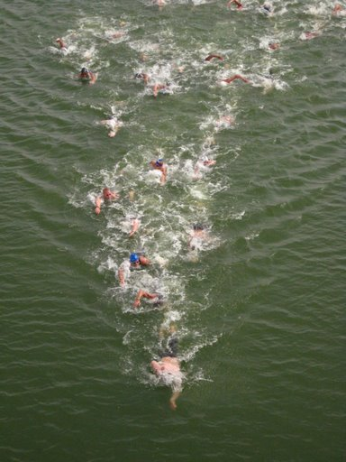  Open water pack race training lead by camp director and Olympian Mark Warkentin  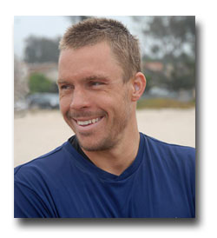

Camp Itinerary  July 3rd  Noon: check-in at Tropicana Gardens and lunch  2pm: camp into with Coach Mark  3pm: swim practice at UCSB Campus Pool (warm-up/loosen)  4pm: depart Campus Pool for Leadbetter Beach  5pm: Santa Barbara beach lifeguard supervised ocean training session  6:30pm: “Nite Moves” race. 1 mile sprint (4 turn rectangle)  7:30pm: depart Leadbetter Beach for Tropicana Gardens  8:00pm: dinner  9:00pm: camp meeting – Coach Mark on Race Analysis and note taking  10:00pm: lights out  July 4th  7am: breakfast  8am: coach Mark on training strategy  10am: Swim practice. Test set of 20x200 descend to fast.  NOON: lunch  2pm: Coach Mark: video analysis of pack swimming and strategy  3pm: Guest speaker on channel crossings: How to organize, prepare for and execute a successful night swim or Channel Crossing  4pm: pool workout and dryland training session (UCSB lagoon/Campus Point)  6pm: dinner  9pm: fireworks at Harder Stadium (UCSB Campus)  10pm: lights out  July 5th  7am: breakfast  8am: coach Mark on starts/turns/finishes  10am: swim practice: test set of 40x100 (37 in pack then 3 sprint)  NOON: lunch  2pm: coach Mark on race strategy development  3pm: depart UCSB for East Beach  4pm: Santa Barbara beach lifeguard supervised ocean training  6:30pm: “Reef and Run” race. 1 mile sprint (4 turn rectangle)  7:30pm: depart east beach for Tropicana gardens  8:00pm: dinner  9:00Pm: camp meeting  10:00pm: lights out  July 6th:  7am: breakfast  8am: depart UCSB for east beach  9am: “Semana Nautica 1 mile ocean race” (4 turn rectangle)  10am: Santa Barbara lifeguard supervised beach training session at East Beach  noon: lunch at East Beach  1pm: participation in Semana Nautica swim meet or return to Tropicana Gardens  5pm: coach Mark on Gamesmanship and competitor psychological analysis  7pm: dinner  8pm: camp meeting  10pm: lights out | UC Santa Barbara campus  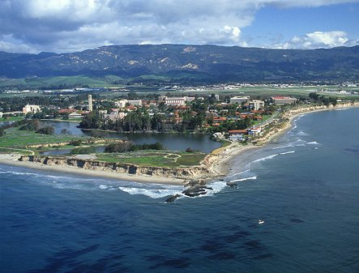  Tropicana Gardens dorms  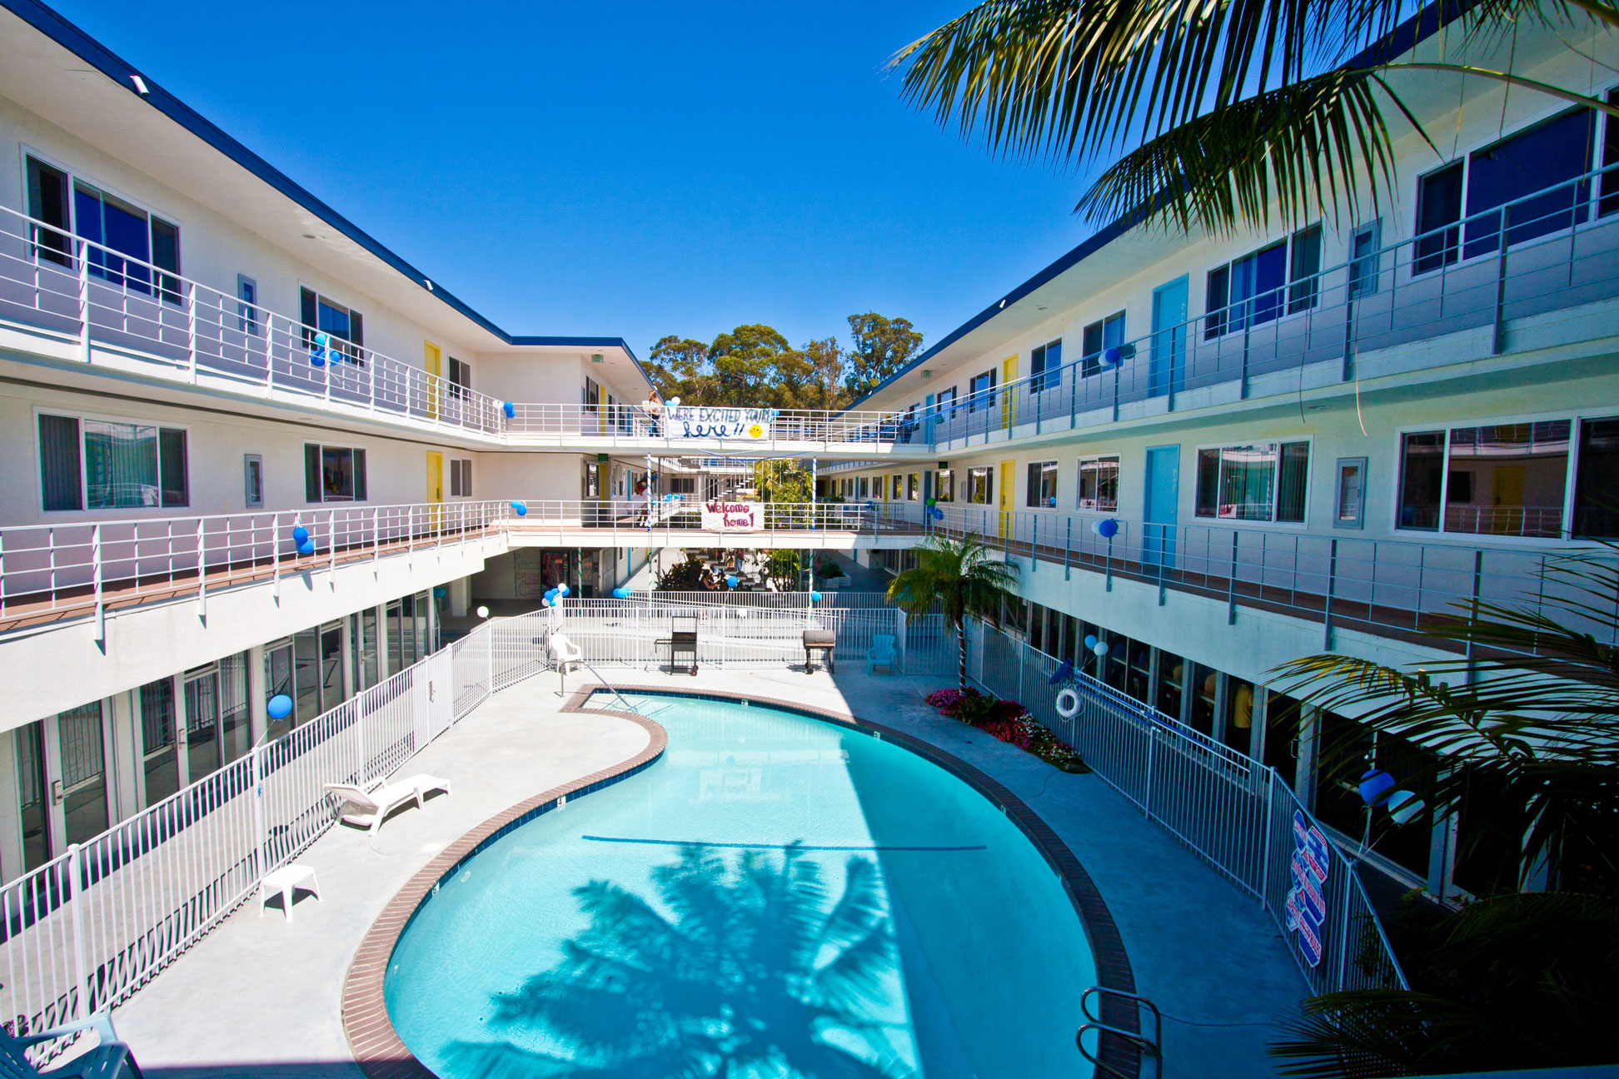  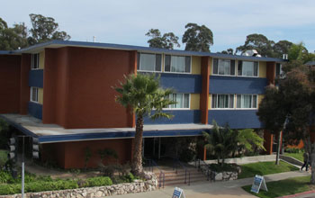  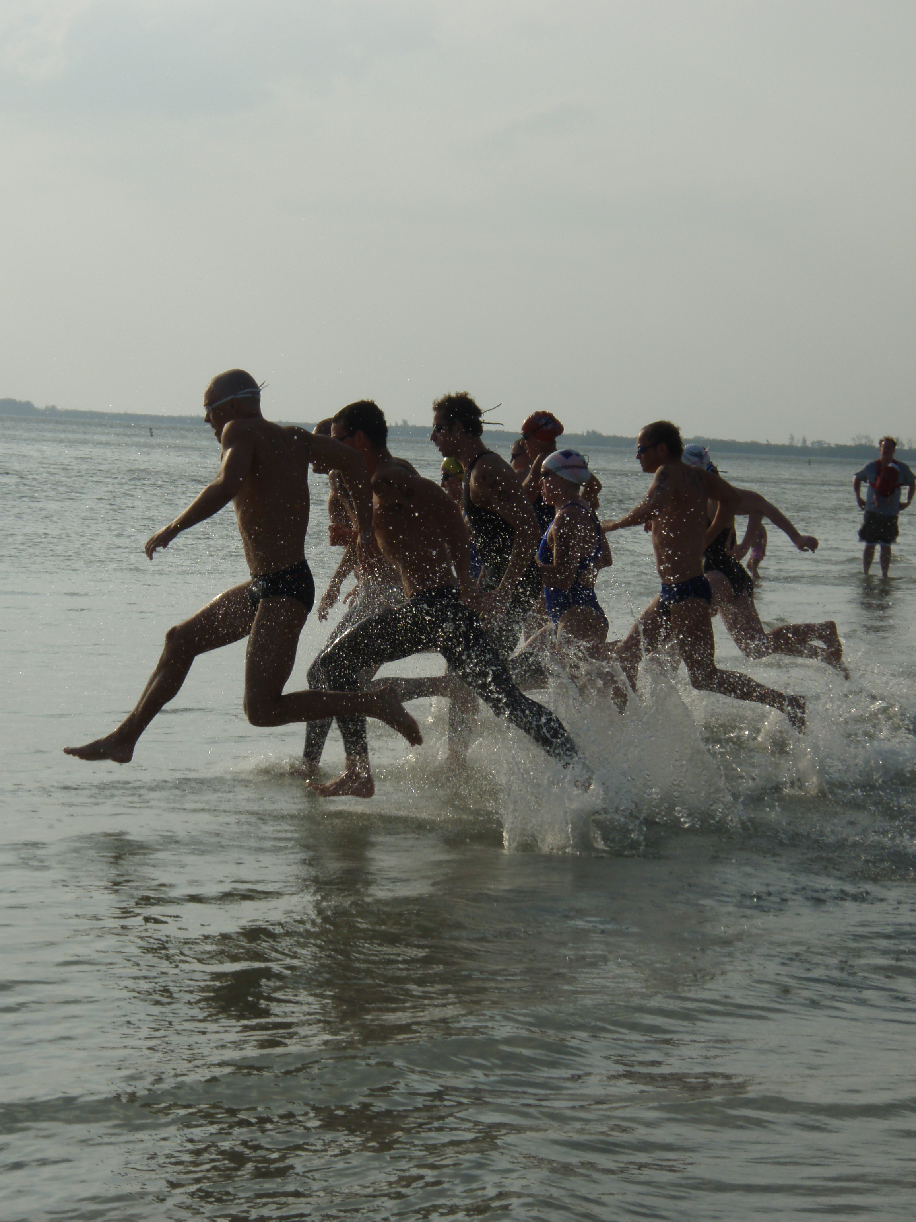  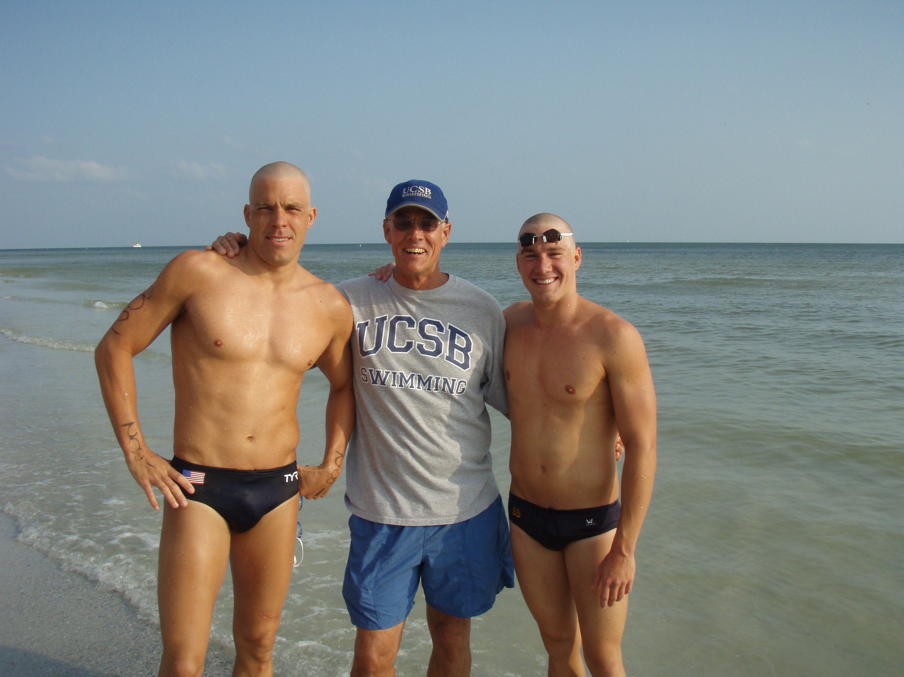

July 7th  7am: breakfast  8am: depart UCSB for East Beach  9am: “Semana Nautica 3 mile ocean race” (6 turn rectangle)  11am: Santa Barbara beach lifeguard supervised training session and camp conclusion  2pm: return to Tropicana gardens and check-out or participation in Semana Nautica pool competition. | The Semana Nautica competition is one of the oldest and most recognized ocean events in the state.  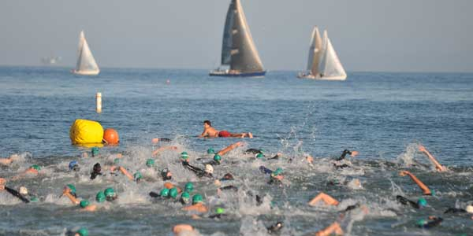

Nite Moves summer Ocean race is held every Wednesday evening in the summer. The race attracts hundreds of local athletes. Camp athletes will train on the course and then compete in the race. | 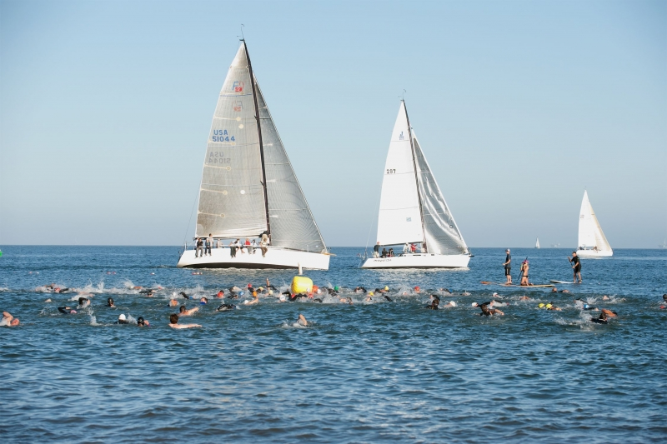

“Reef and Run” in front of the historic Santa Barbara Bathhouse with race lifeguards both in the water and on land.


